Day 3 – Class & Home Assignment:
- Bug Reporting Dashboard Generator:
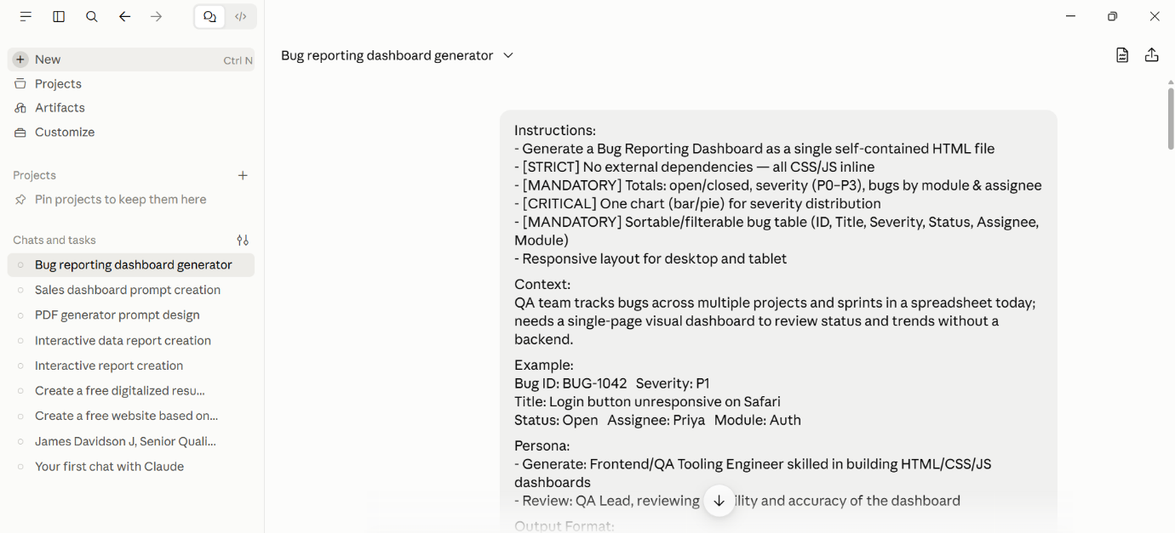
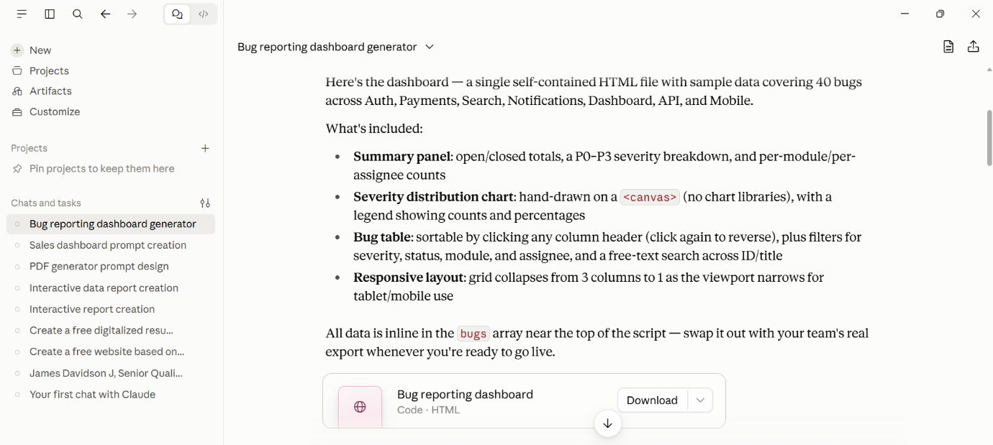
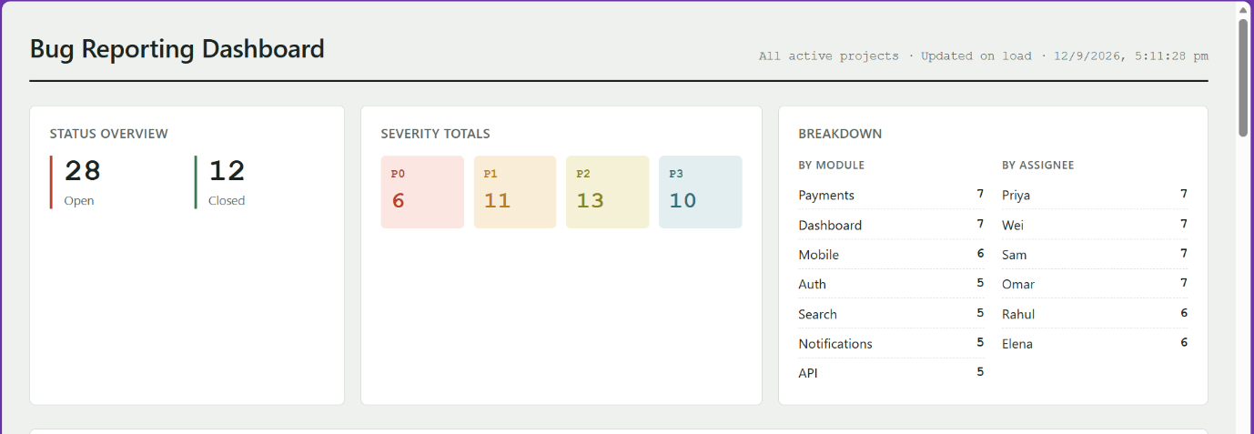
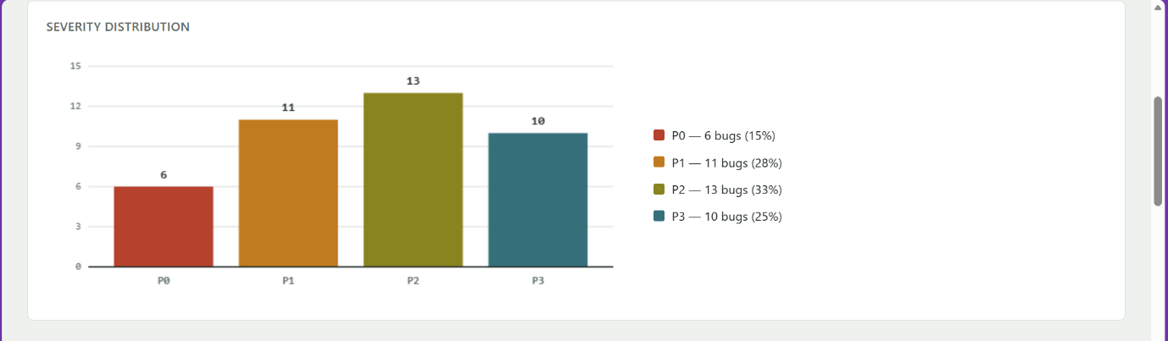
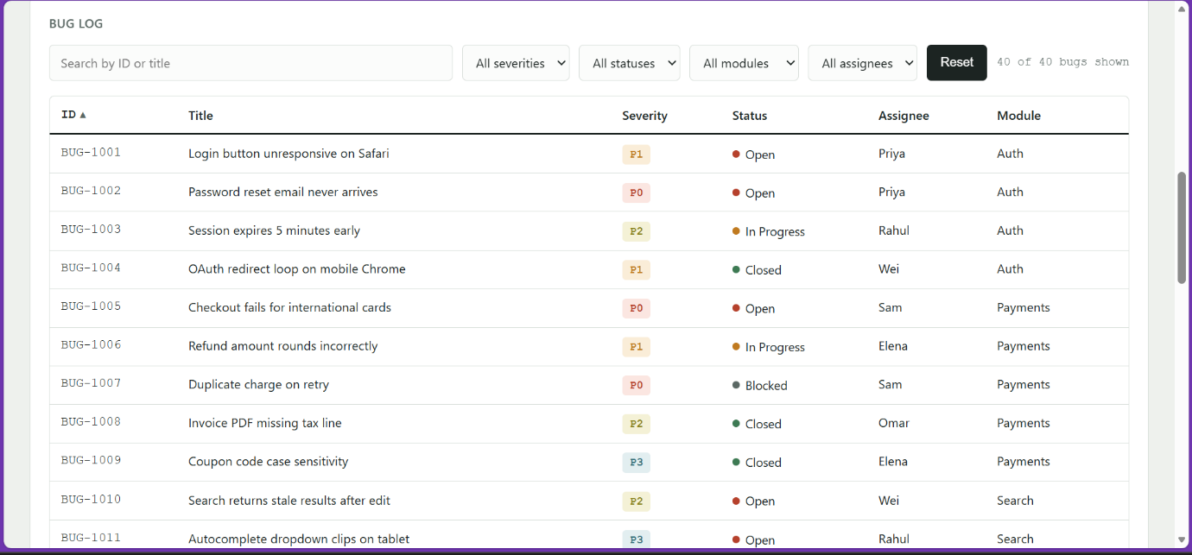
- Banking Fund Transfer Test cases:
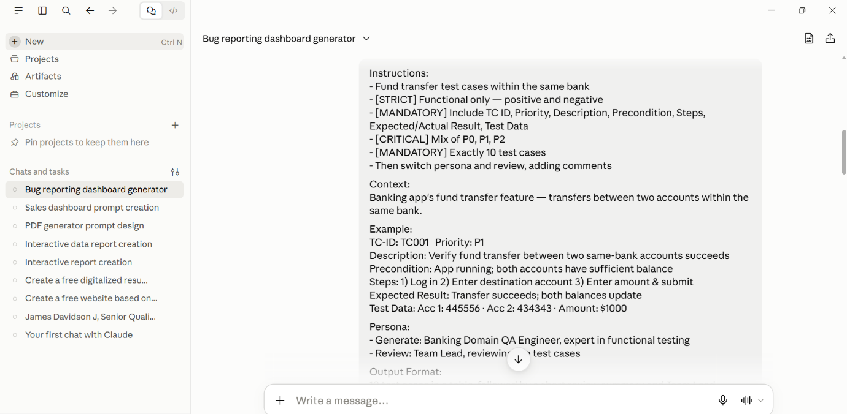
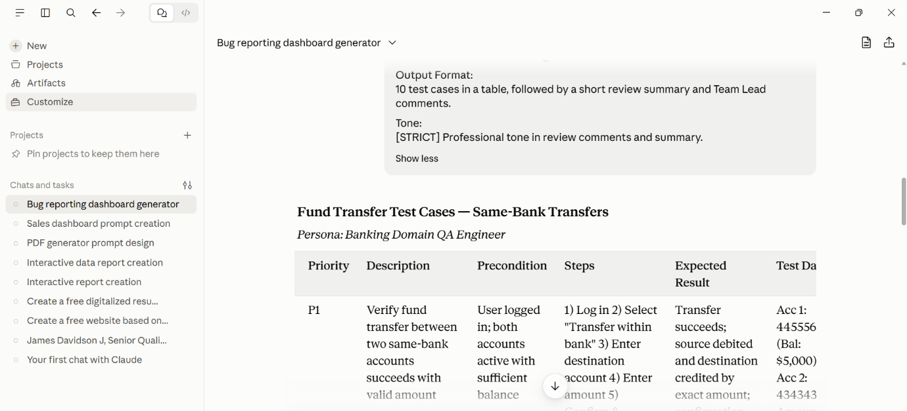
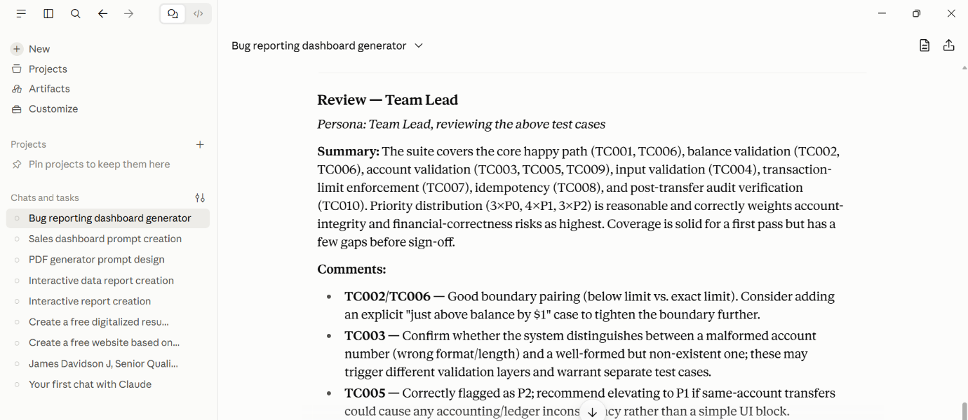
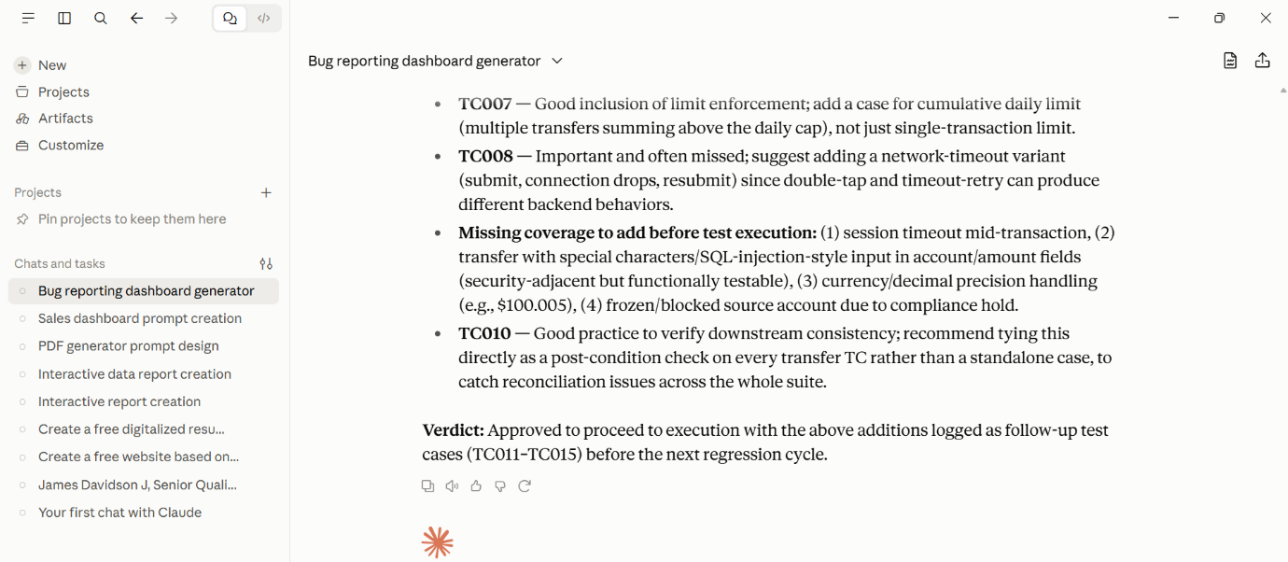
- Regression Prioritization:
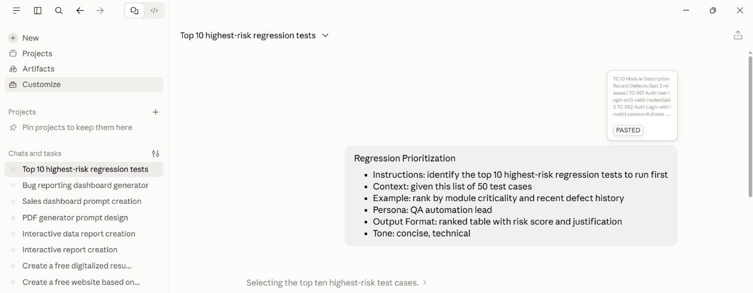
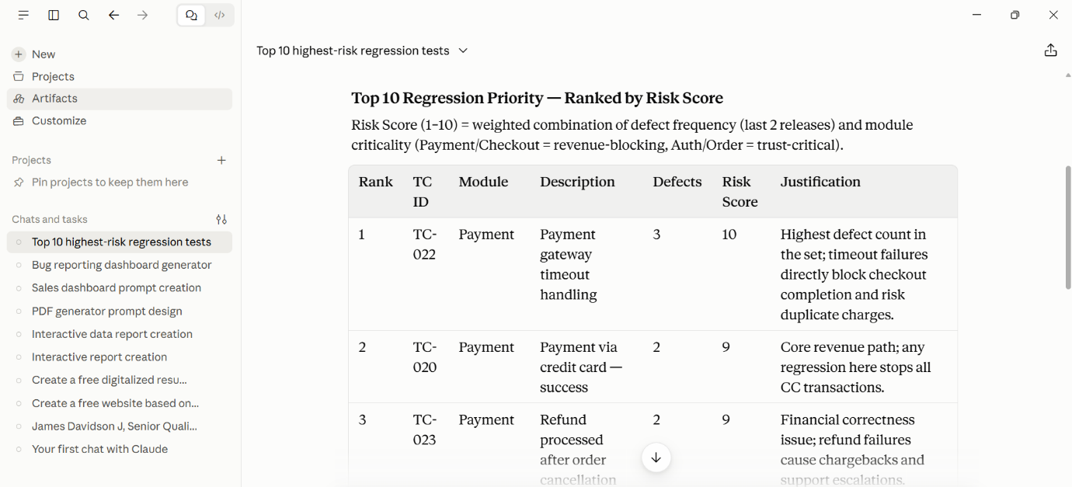
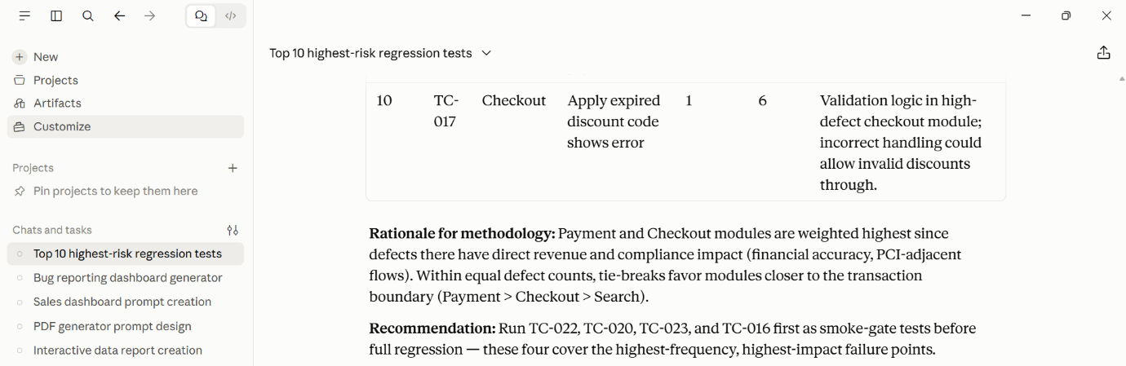
- Test Data Generation:
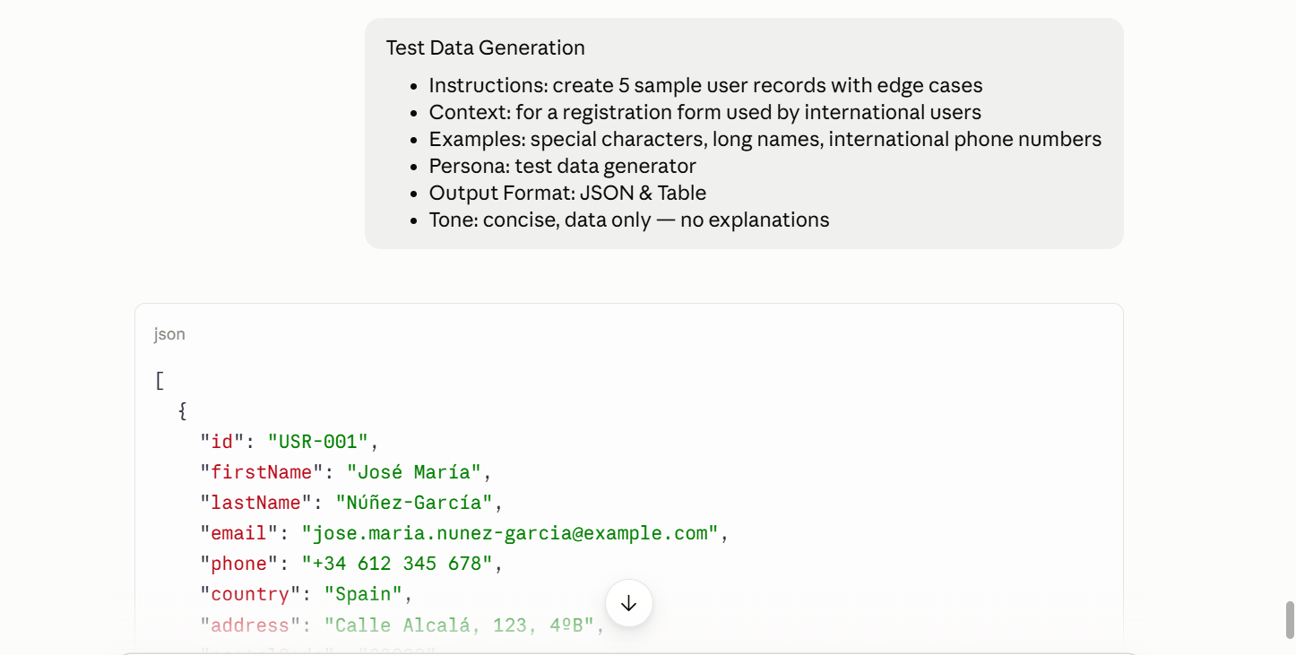
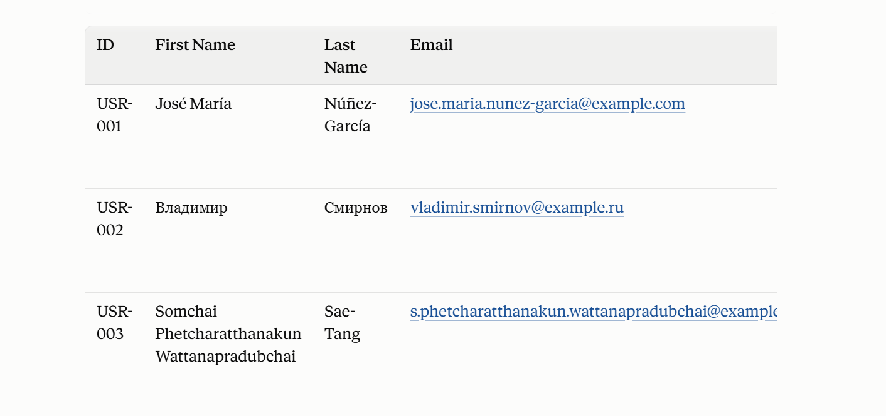
- Selenium- Javascript Generator:
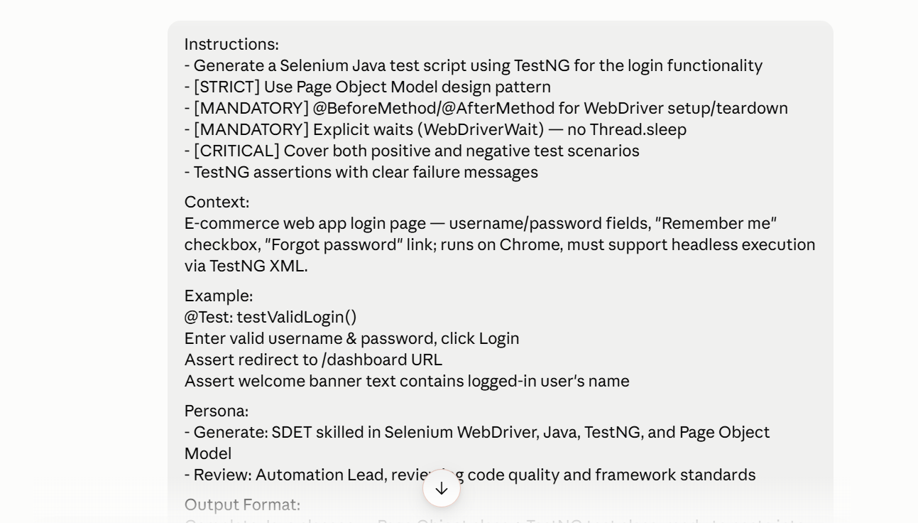

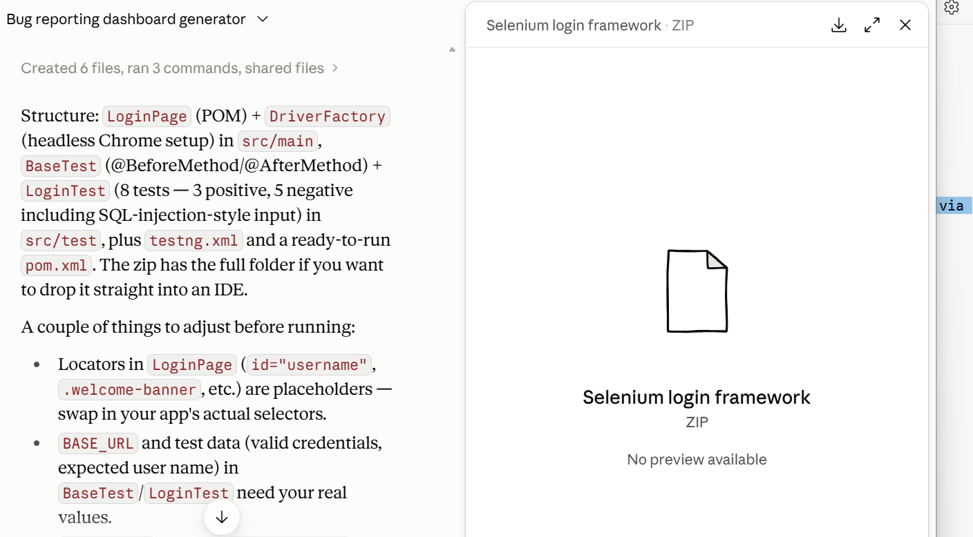
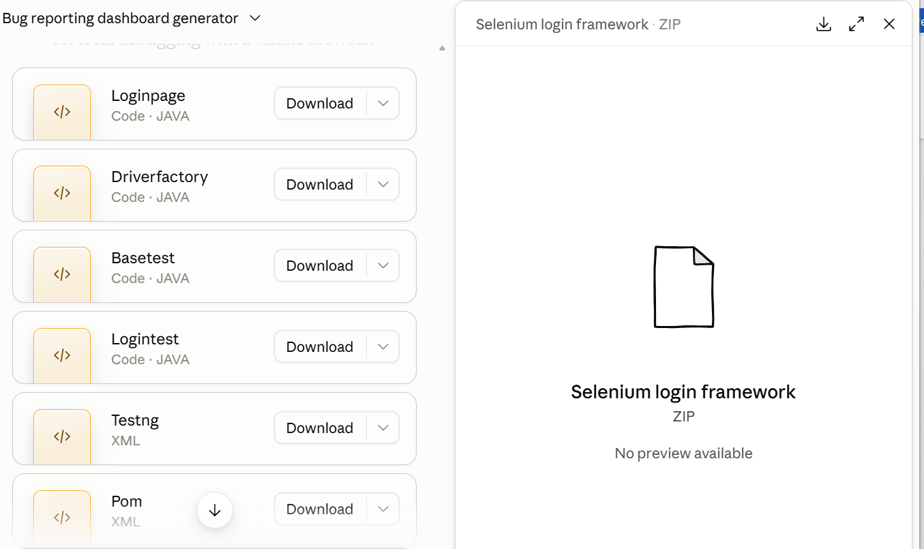
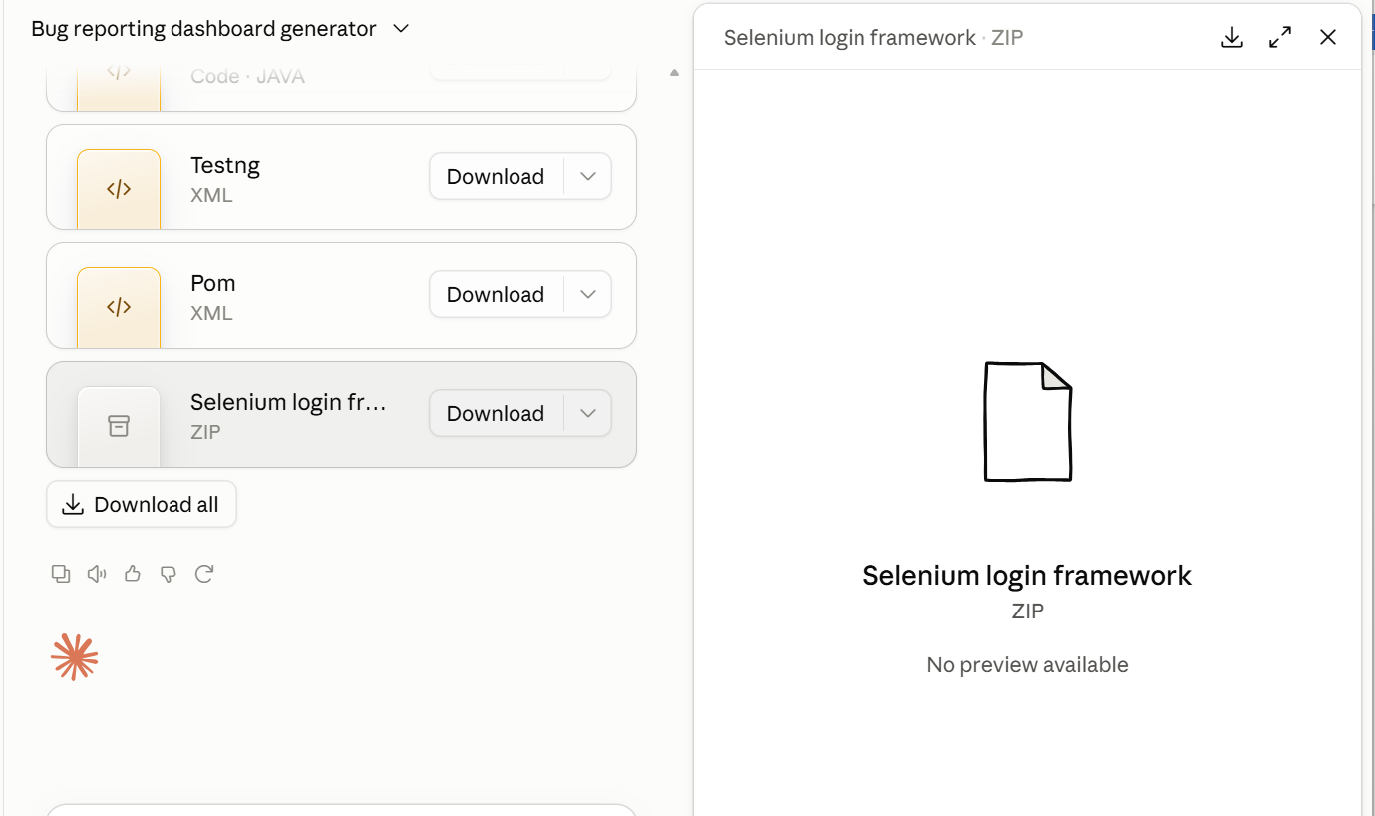
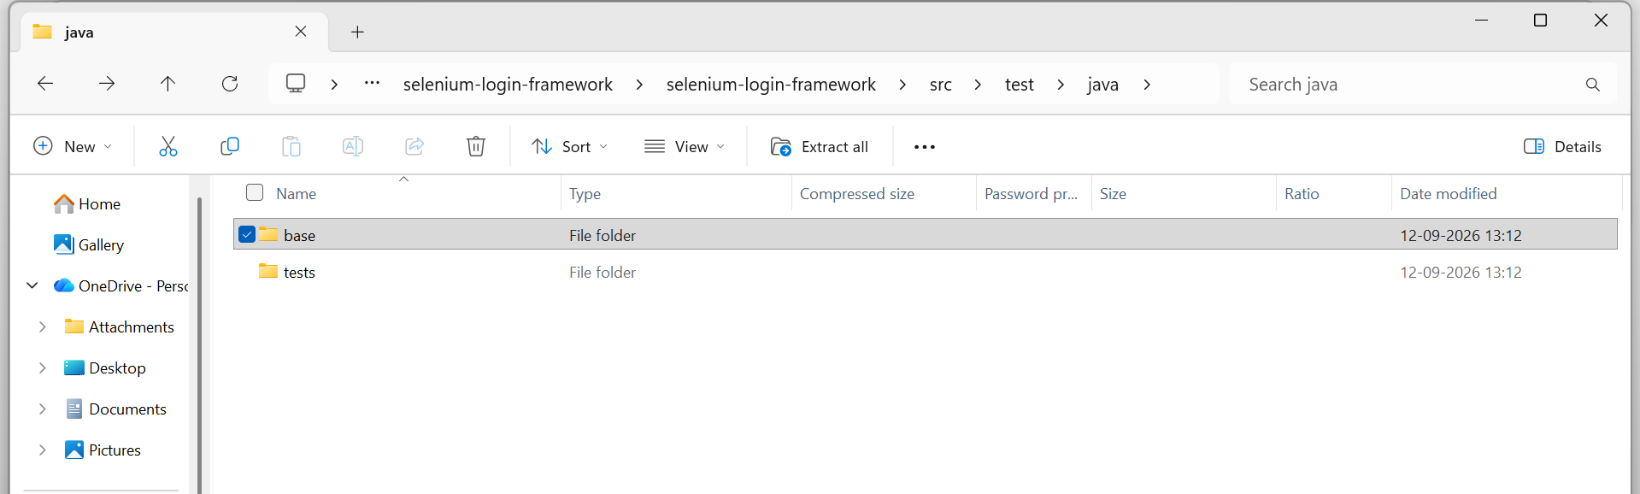
Interactive CoT:
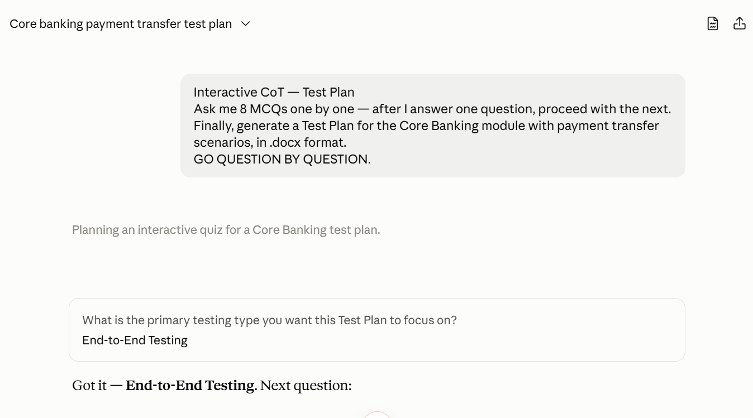
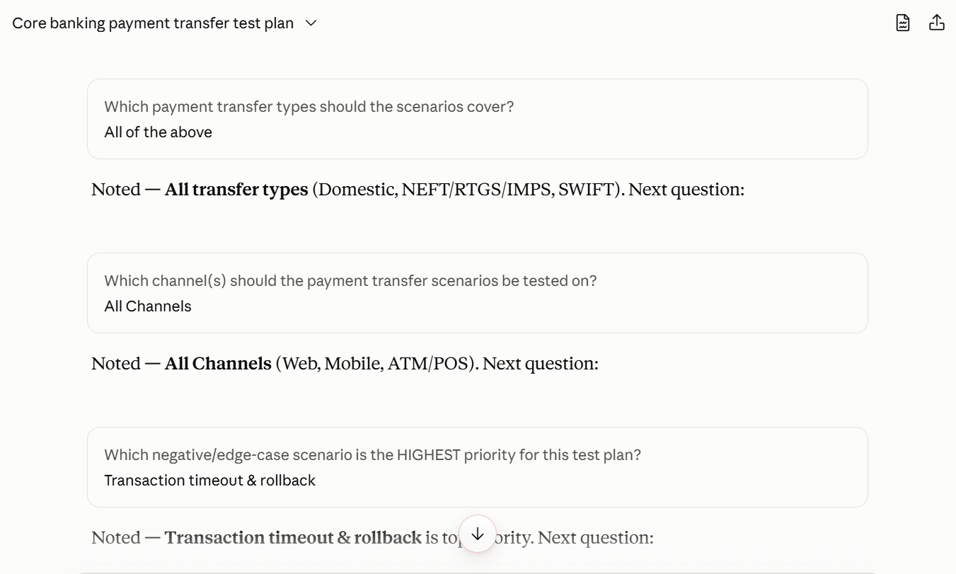

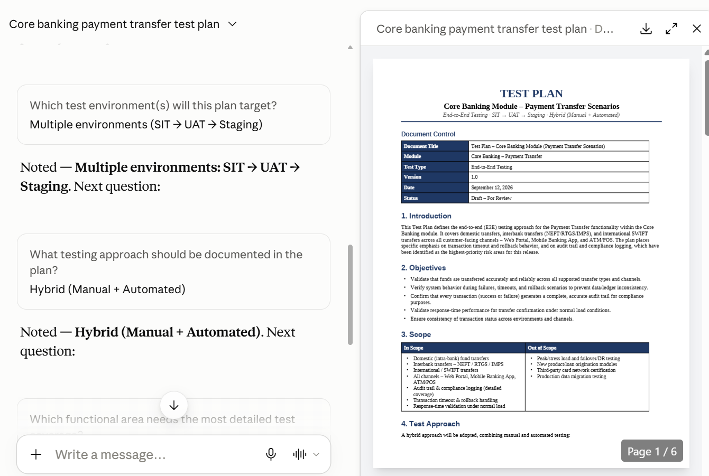
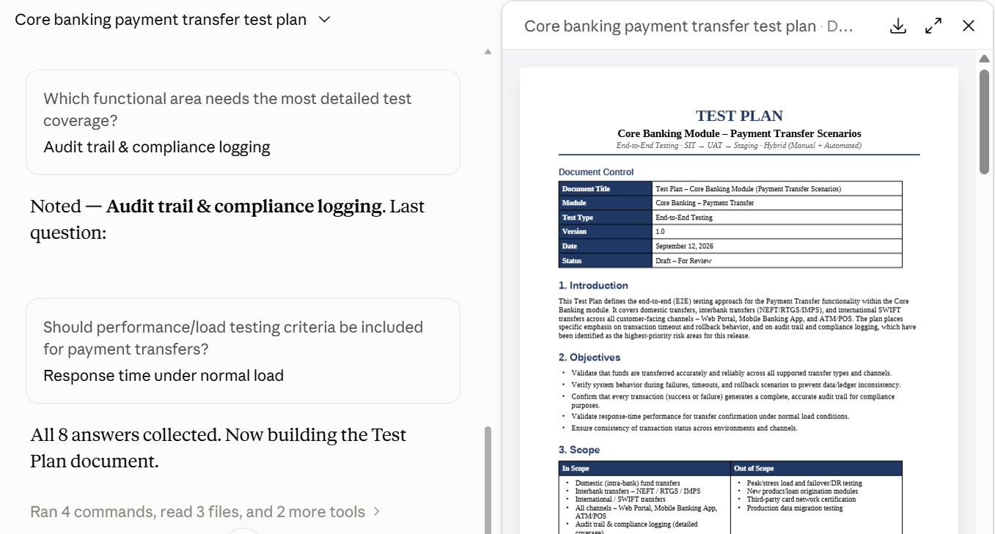
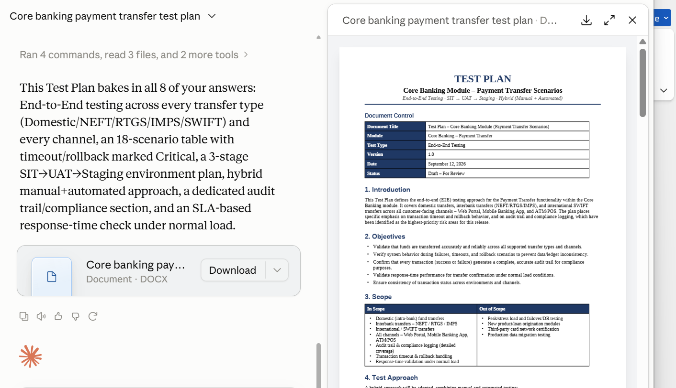
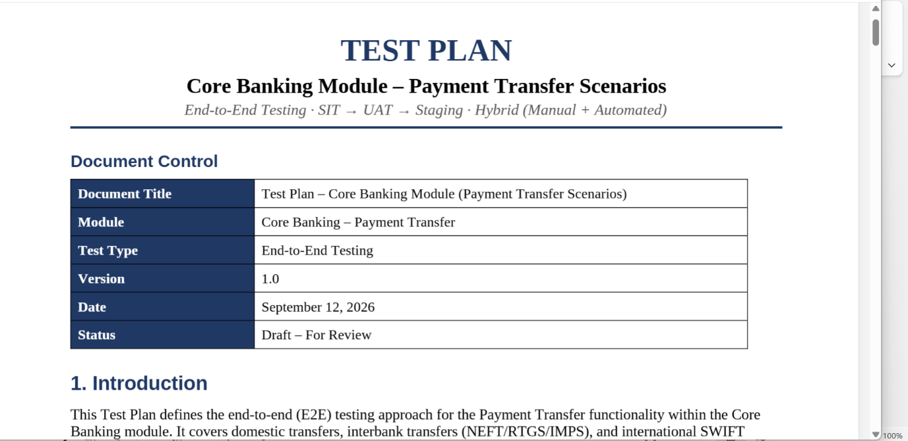
Home Assignments:
- Promptathon
Search Functionality:
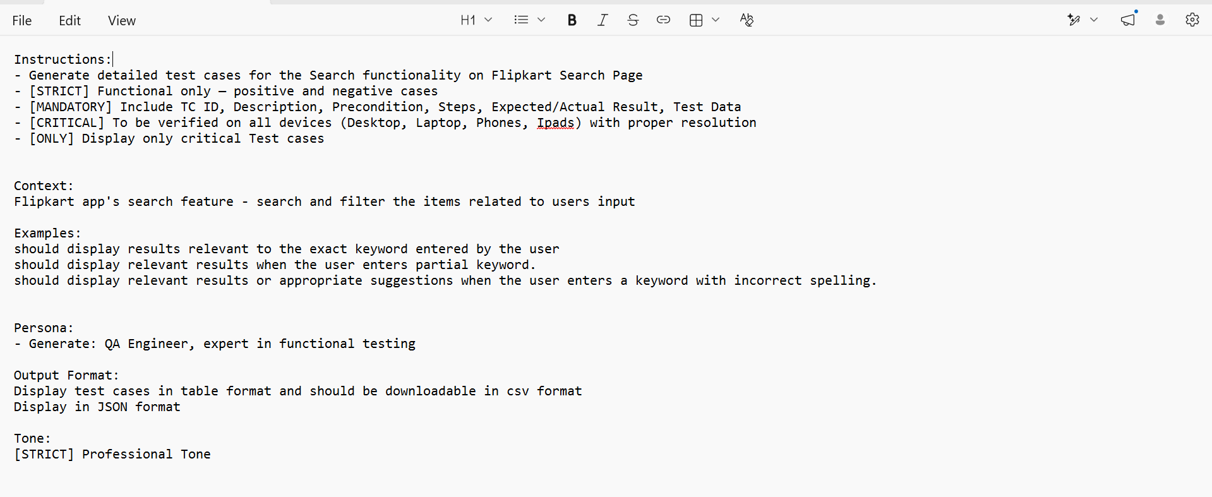
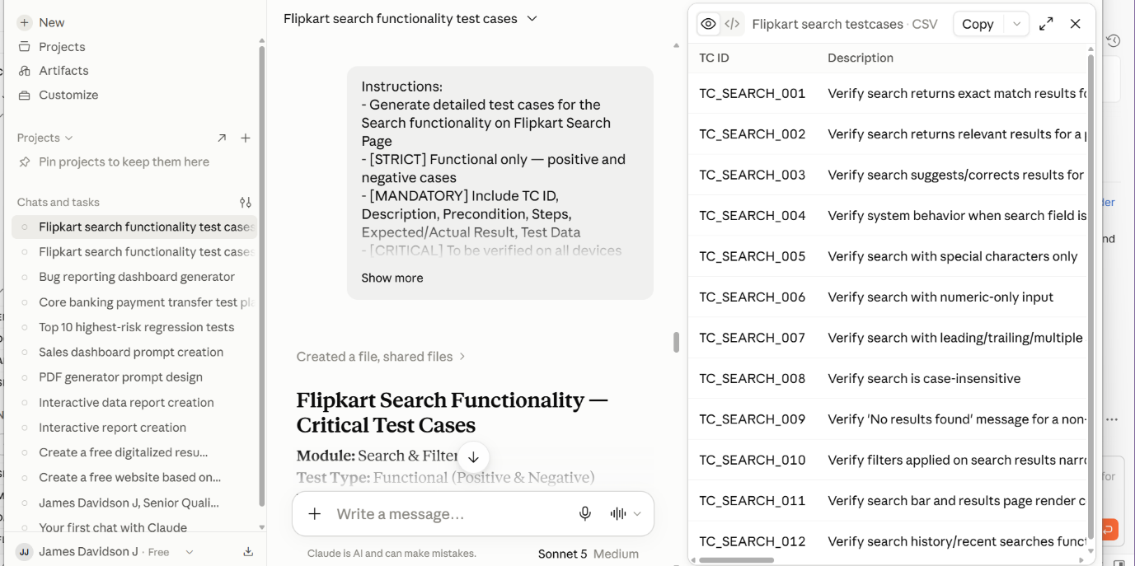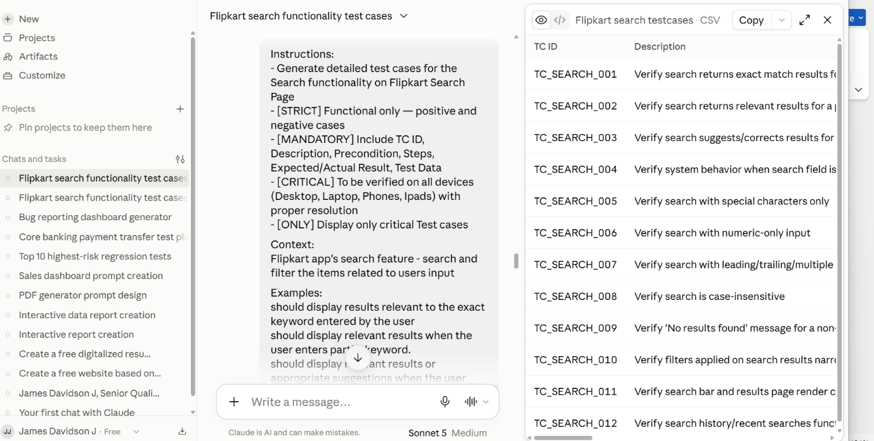
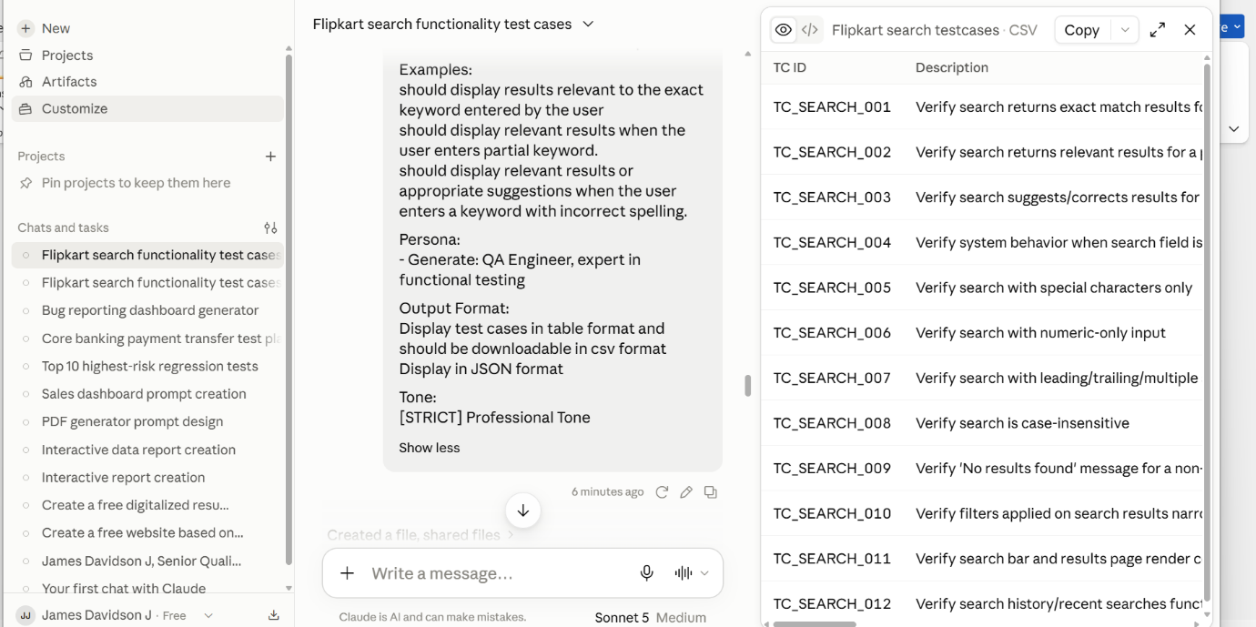
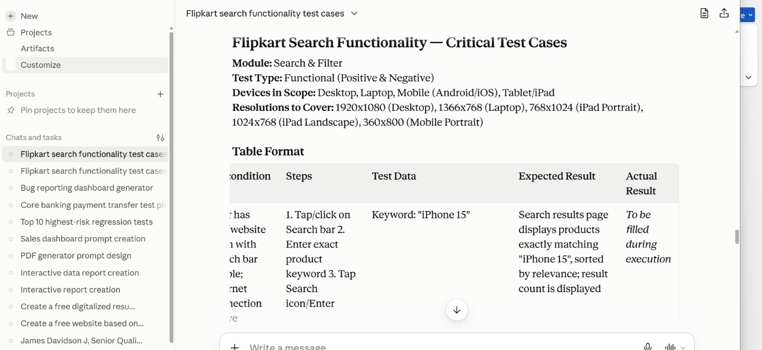
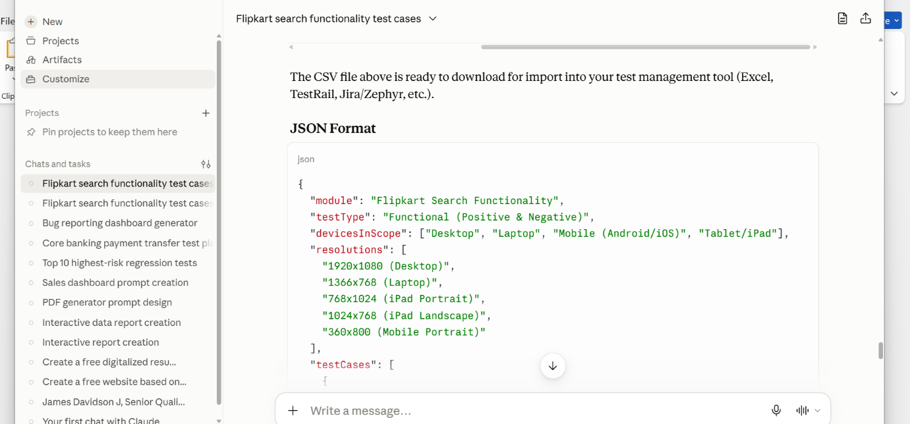
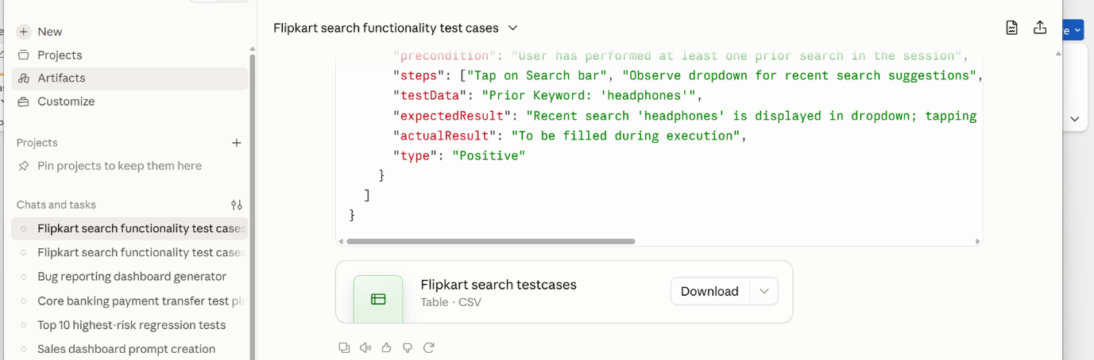
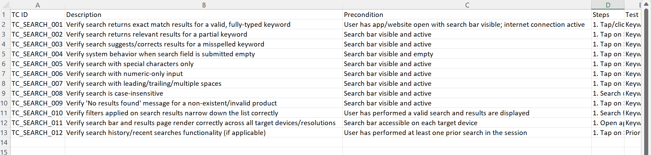

2. File Upload:
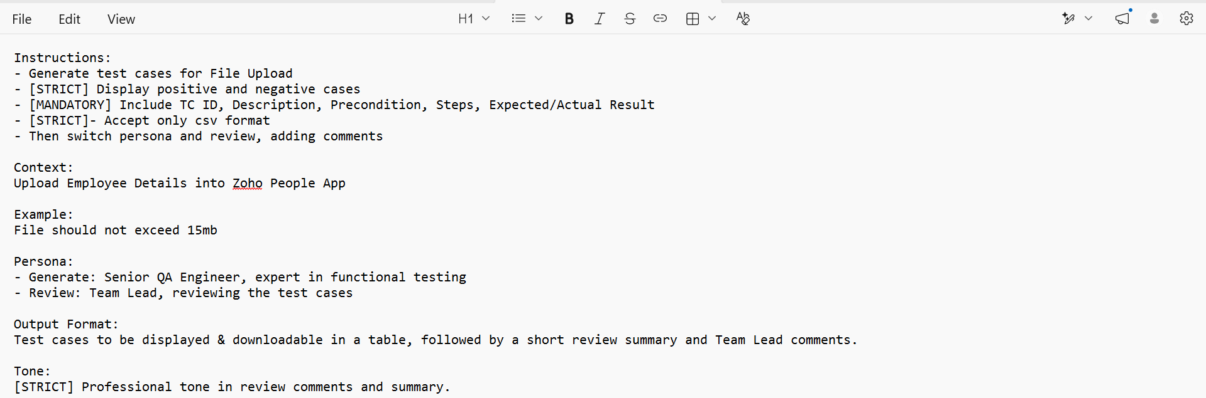
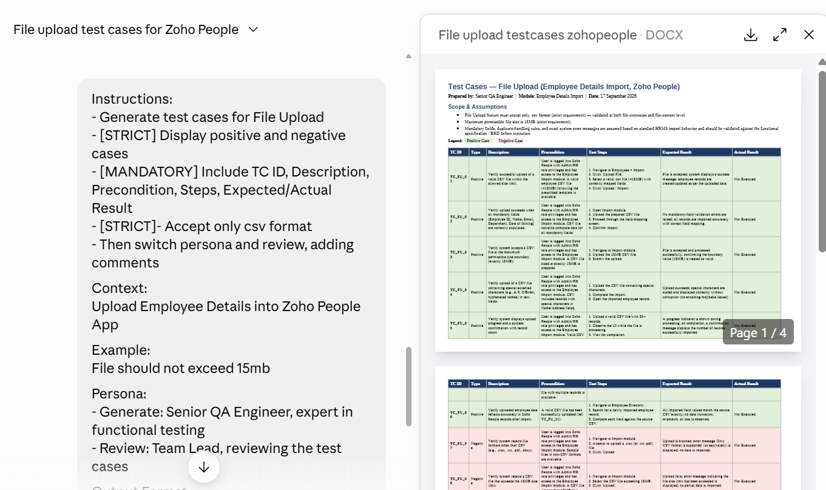
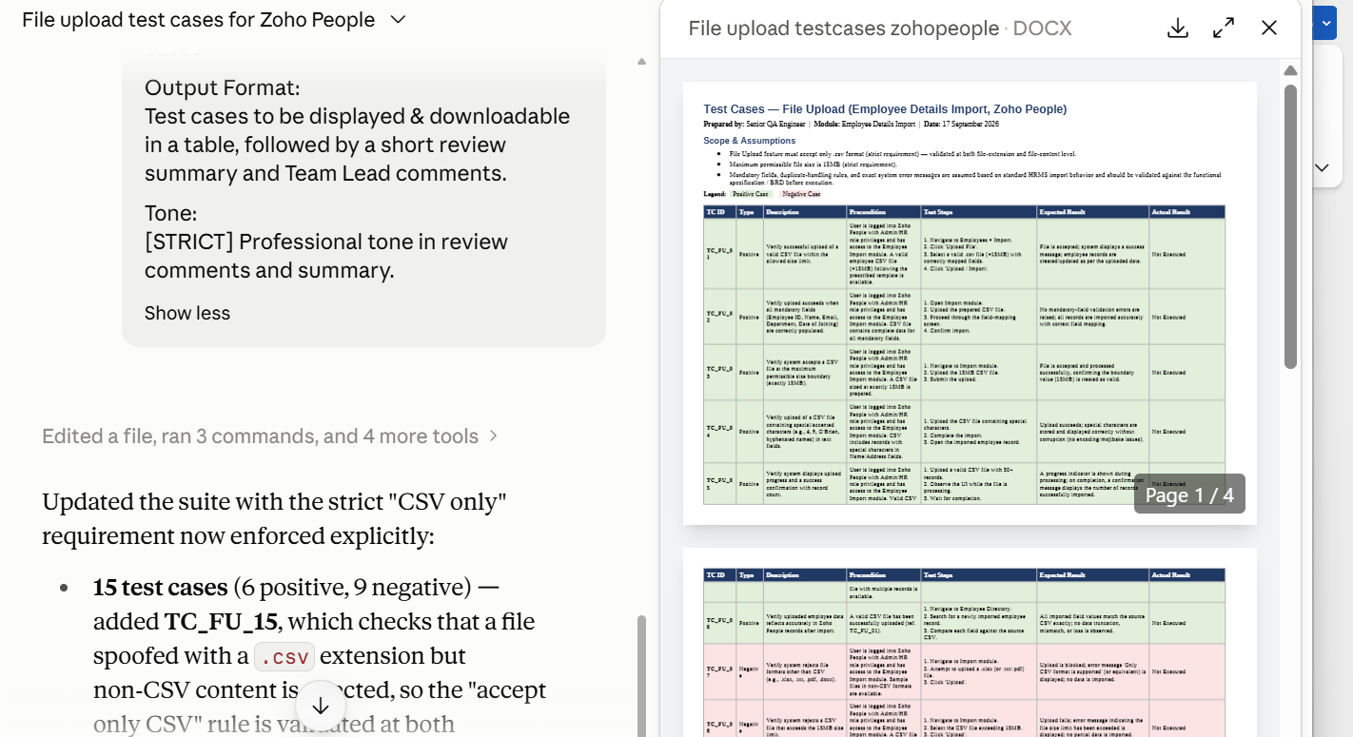
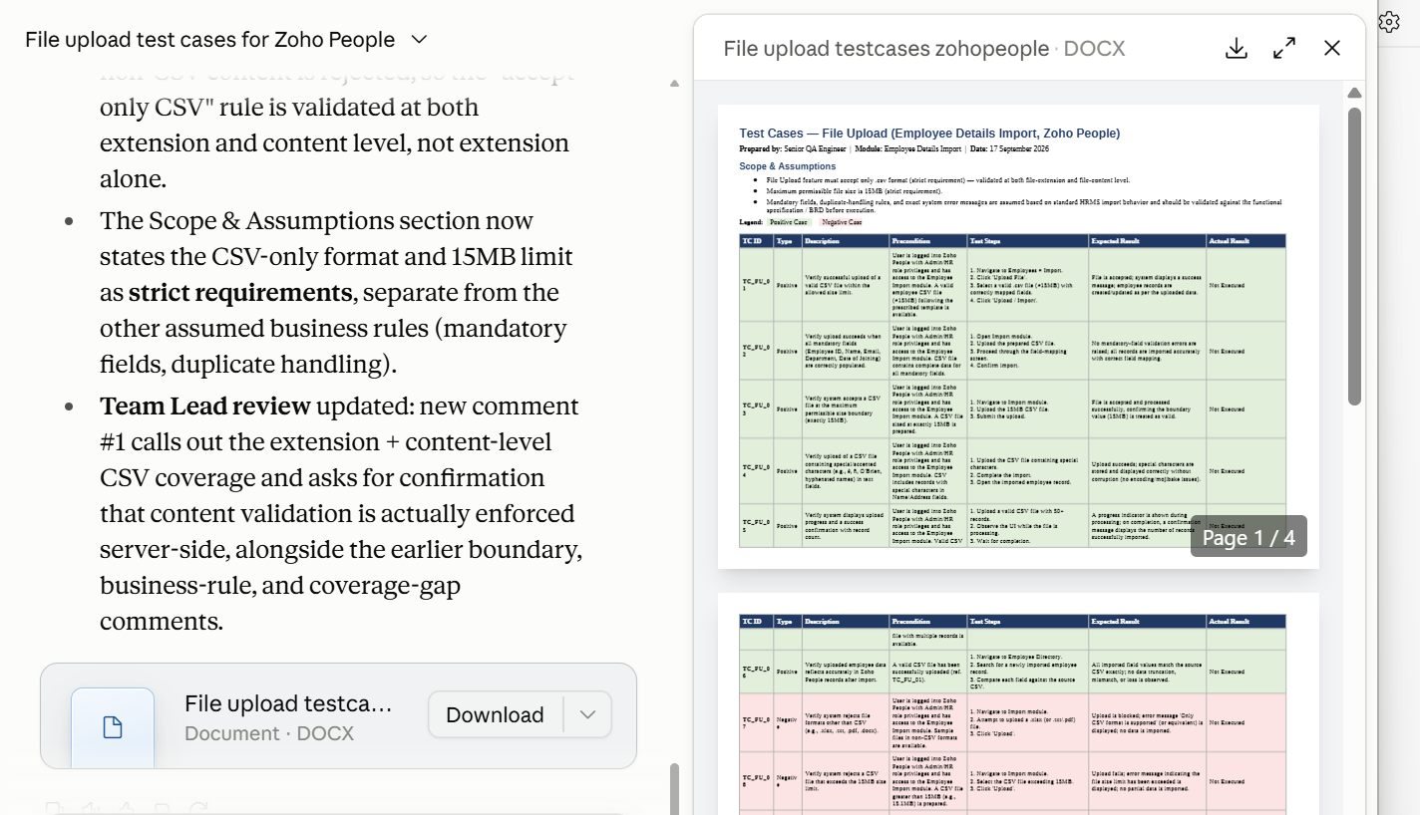
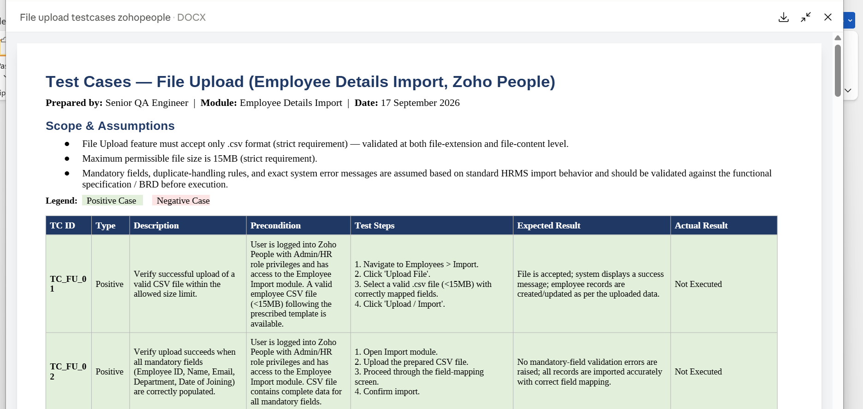
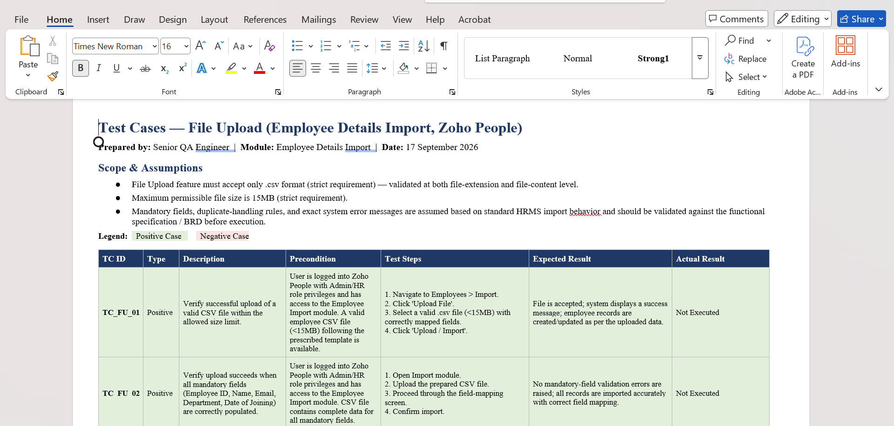
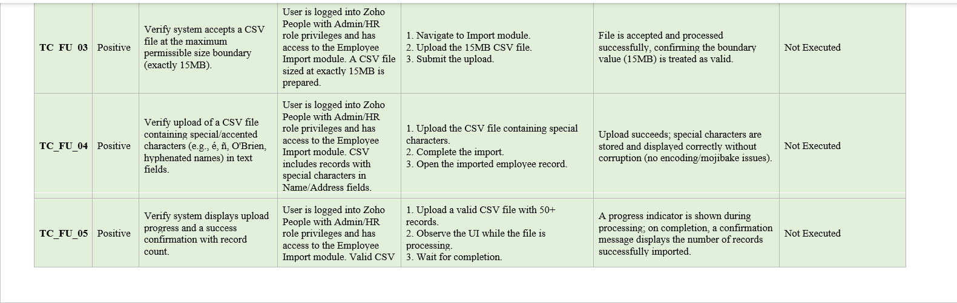
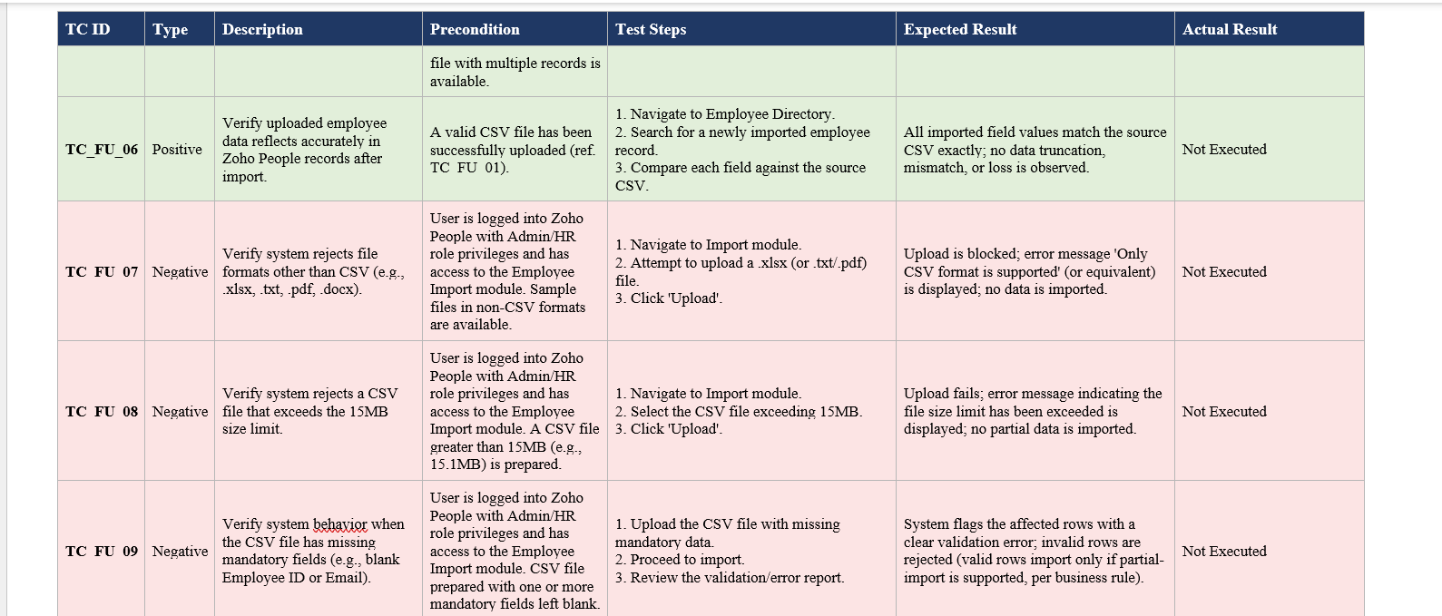
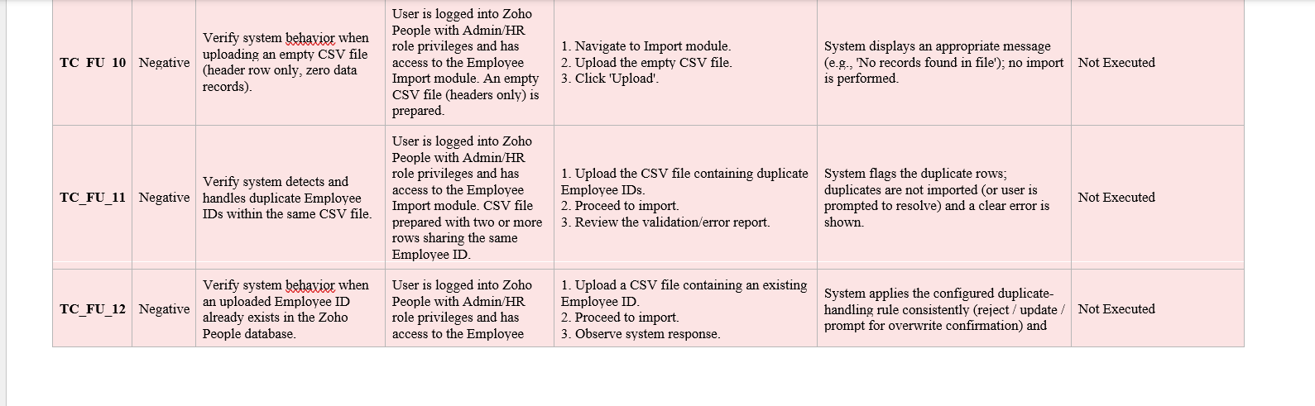
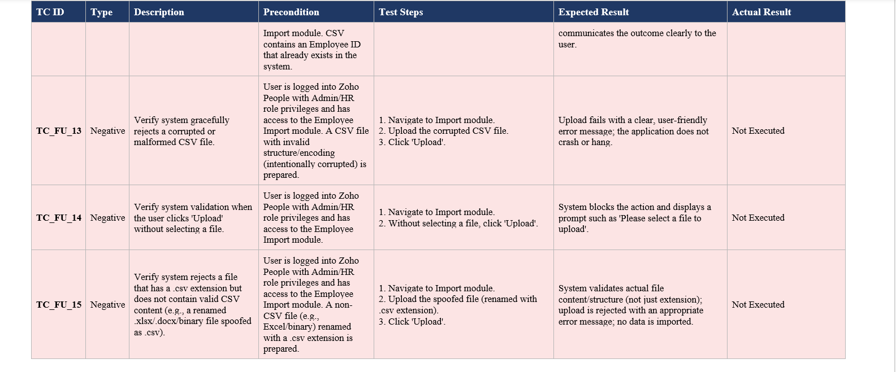
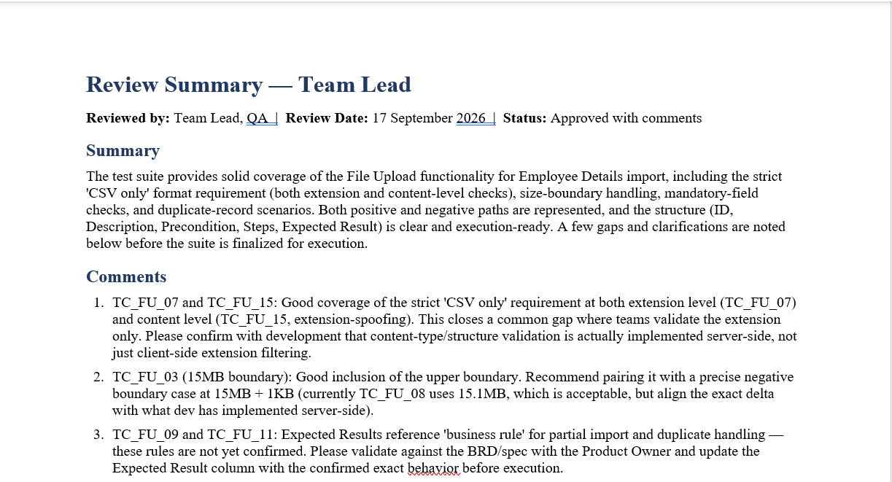
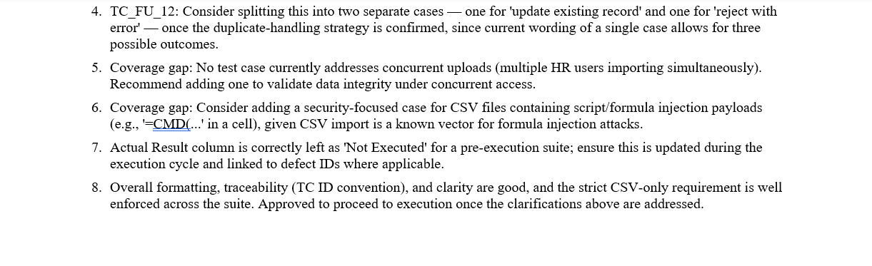
3. Mobile App – OTP Login:
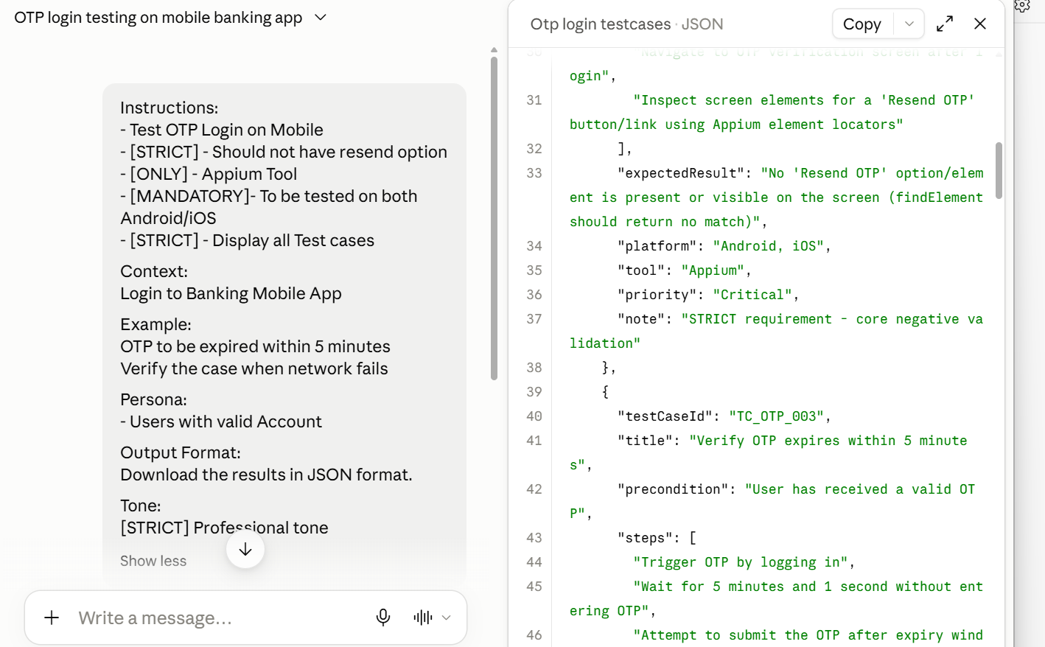
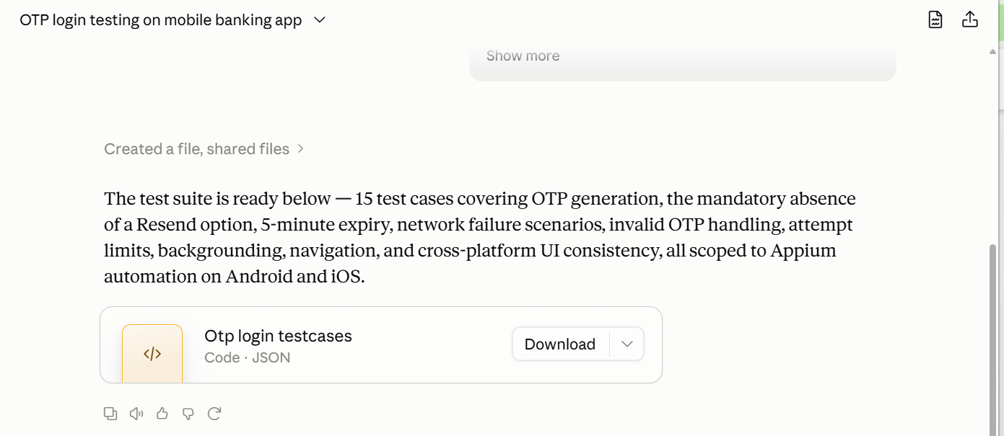
Json Output:
{
"testSuite": "OTP Login - Banking Mobile Application",
"persona": "Users with valid Account",
"automationTool": "Appium",
"platformsCovered": [
"Android",
"iOS"
],
"generatedOn": "2026-09-17",
"testCases": [
{
"testCaseId": "TC_OTP_001",
"title": "Verify OTP is triggered on valid login credentials",
"precondition": "User has a valid, registered bank account and app is installed",
"steps": [
"Launch the banking app",
"Enter valid Username/Account ID and Password",
"Tap on Login button"
],
"expectedResult": "OTP is sent to the registered mobile number/email and OTP entry screen is displayed",
"platform": "Android, iOS",
"tool": "Appium",
"priority": "High"
},
{
"testCaseId": "TC_OTP_002",
"title": "Verify Resend OTP option is NOT displayed",
"precondition": "User is on the OTP entry screen",
"steps": [
"Navigate to OTP verification screen after login",
"Inspect screen elements for a 'Resend OTP' button/link using Appium element locators"
],
"expectedResult": "No 'Resend OTP' option/element is present or visible on the screen (findElement should return no match)",
"platform": "Android, iOS",
"tool": "Appium",
"priority": "Critical",
"note": "STRICT requirement - core negative validation"
},
{
"testCaseId": "TC_OTP_003",
"title": "Verify OTP expires within 5 minutes",
"precondition": "User has received a valid OTP",
"steps": [
"Trigger OTP by logging in",
"Wait for 5 minutes and 1 second without entering OTP",
"Attempt to submit the OTP after expiry window"
],
"expectedResult": "System rejects the OTP with an 'OTP expired' message; user is not logged in",
"platform": "Android, iOS",
"tool": "Appium",
"priority": "High"
},
{
"testCaseId": "TC_OTP_004",
"title": "Verify OTP is accepted within the valid 5-minute window",
"precondition": "User has received a valid OTP",
"steps": [
"Trigger OTP by logging in",
"Enter the correct OTP within 5 minutes",
"Tap Submit/Verify"
],
"expectedResult": "User is successfully logged in and navigated to the dashboard/home screen",
"platform": "Android, iOS",
"tool": "Appium",
"priority": "High"
},
{
"testCaseId": "TC_OTP_005",
"title": "Verify behavior when network fails during OTP request",
"precondition": "User enters valid login credentials",
"steps": [
"Disable network/enable airplane mode using device settings via Appium driver",
"Tap Login to trigger OTP request",
"Observe app behavior"
],
"expectedResult": "App displays an appropriate network error message; OTP screen is not loaded; no crash occurs",
"platform": "Android, iOS",
"tool": "Appium",
"priority": "High"
},
{
"testCaseId": "TC_OTP_006",
"title": "Verify behavior when network fails during OTP submission",
"precondition": "User is on OTP screen with a valid OTP received",
"steps": [
"Enter the correct OTP",
"Disable network before tapping Submit",
"Tap Submit/Verify"
],
"expectedResult": "App displays a network failure error message and allows retry once network is restored; OTP entry is not lost",
"platform": "Android, iOS",
"tool": "Appium",
"priority": "High"
},
{
"testCaseId": "TC_OTP_007",
"title": "Verify error message on entering incorrect OTP",
"precondition": "User is on OTP entry screen",
"steps": [
"Enter an incorrect/invalid OTP",
"Tap Submit/Verify"
],
"expectedResult": "System displays an 'Invalid OTP' error message and login is not allowed",
"platform": "Android, iOS",
"tool": "Appium",
"priority": "High"
},
{
"testCaseId": "TC_OTP_008",
"title": "Verify OTP field accepts only numeric input",
"precondition": "User is on OTP entry screen",
"steps": [
"Attempt to enter alphabetic/special characters into the OTP input field"
],
"expectedResult": "OTP field rejects non-numeric input or does not accept the characters",
"platform": "Android, iOS",
"tool": "Appium",
"priority": "Medium"
},
{
"testCaseId": "TC_OTP_009",
"title": "Verify maximum OTP attempt limit and account lock behavior",
"precondition": "User is on OTP entry screen",
"steps": [
"Enter incorrect OTP repeatedly until the maximum allowed attempts are reached"
],
"expectedResult": "Account/session is locked or blocked as per policy after the defined maximum incorrect attempts, with an appropriate message",
"platform": "Android, iOS",
"tool": "Appium",
"priority": "High"
},
{
"testCaseId": "TC_OTP_010",
"title": "Verify OTP screen behavior when app is backgrounded and resumed",
"precondition": "User is on OTP entry screen with active OTP",
"steps": [
"Send the app to background",
"Wait for a short duration",
"Resume the app to foreground"
],
"expectedResult": "OTP screen state is retained correctly; timer (if any) continues accurately; no data loss or crash",
"platform": "Android, iOS",
"tool": "Appium",
"priority": "Medium"
},
{
"testCaseId": "TC_OTP_011",
"title": "Verify back navigation from OTP screen",
"precondition": "User is on OTP entry screen",
"steps": [
"Tap the device back button (Android) or swipe-back gesture (iOS)"
],
"expectedResult": "User is navigated back to the login screen or an appropriate confirmation is shown; session is handled securely",
"platform": "Android, iOS",
"tool": "Appium",
"priority": "Medium"
},
{
"testCaseId": "TC_OTP_012",
"title": "Verify OTP auto-read/auto-fill functionality (if supported)",
"precondition": "SMS-based OTP auto-fill is supported on device",
"steps": [
"Trigger OTP via login",
"Receive OTP SMS on device",
"Observe if OTP field auto-populates"
],
"expectedResult": "OTP is auto-filled correctly without manual entry, where platform supports this feature",
"platform": "Android, iOS",
"tool": "Appium",
"priority": "Low"
},
{
"testCaseId": "TC_OTP_013",
"title": "Verify UI consistency of OTP screen across platforms",
"precondition": "App is installed on both Android and iOS devices",
"steps": [
"Navigate to OTP screen on Android device",
"Navigate to OTP screen on iOS device",
"Compare layout, field labels, timer display, and buttons using Appium screenshots/element checks"
],
"expectedResult": "OTP screen UI and functional elements are consistent across Android and iOS, with no Resend option on either platform",
"platform": "Android, iOS",
"tool": "Appium",
"priority": "Medium"
},
{
"testCaseId": "TC_OTP_014",
"title": "Verify OTP timer countdown display accuracy",
"precondition": "User is on OTP entry screen",
"steps": [
"Observe the countdown timer from the moment OTP is triggered",
"Validate timer decrements correctly down to 0 at the 5-minute mark"
],
"expectedResult": "Timer accurately counts down from 5:00 to 0:00 without discrepancy",
"platform": "Android, iOS",
"tool": "Appium",
"priority": "Medium"
},
{
"testCaseId": "TC_OTP_015",
"title": "Verify session termination after OTP expiry",
"precondition": "OTP has expired without submission",
"steps": [
"Allow OTP to expire (5+ minutes)",
"Attempt to proceed without re-login"
],
"expectedResult": "User session is terminated; user is redirected to the login screen requiring fresh credentials",
"platform": "Android, iOS",
"tool": "Appium",
"priority": "High"
}
]
}

